**SELECTION OF COMMUNICATIONS:**

*  In vehicle and outside of the vehicle communications are fast growing technology areas in automotive applications.
*  Automotive communications networks have typically used LANs (local area networks) of the CAN (Control area Networks) variety.
*  The GM Hywire concept vehicle, for example, is advertised as a completely x-by-wire architecture, but CAN networks are converting over to protocols that are more fault tolerant and have guaranteed communications times and no issues with message latency as has been common for multiple access collision detection (MA/CD) protocols in the past.
*  Time triggered protocols (TTP) have been proposed for many years and are now beginning to enter the automotive arena as a new protocol derived from a TTP/ C basis known as FlexRay

To understand automotive communications, it is important to understand the basics of networked communications. In 1983 the Open Systems Interconnection (OSI) committee of the International Standards Organization (ISO) developed a layered model to describe how two different computer systems may share files with each other over a common network.

This OSI model became the industry standard, 7-layered network functionality, open architecture network used universally.

In Figure 5.13, an application running on the computer at Node A is sending a packet of data to a remote computer running at Node B over a communications channel. The communications channel may be cable, twisted pair or wireless.

The arrows indicate the progress of the packet of data, for example, an engineering drawing, as it moves from application layer 7 on computer A to applications layer 7 on computer B.

This process describes very closely how the procedure of email, file transfer, Internet web browsers etc. work.

Figure 5.13 OSI 7-layer network model The OSI seven layers are defined as follows:

1. Physical. The modem and wire or other channel connecting to nodes. The channel may be coaxial cable, twisted pair copper wire, fibre-optic cable, radio or infrared links etc.

2. Data link. Describes how the nodes of the network obtain access and share the physical connections to the channel. Physical address of a node, or its media access control, is defined at layer 2. For example, Internet service provider point to point control for dial up access is defined at this data link layer.

3. Network. This layer takes care of routing data packets to nodes that may not even be on the same LAN as computer A, for instance. The network layer contains logical rather than physical addresses and the routing mechanisms needed to access remote LANs or wide area networks (WANs). This is where Internet protocol (IP), for example, resides.

4. Transport. The layer that acknowledges message transmission across the network and validates that transmission has occurred without loss of data. If a data packet is lost, this layer is responsible for resending the data packet and confirming it was received and placed back into the correct sequence. This layer is called TCP for transmission control protocol.

5. Session. The session layer maintains an open communications channel between two separate nodes during transmission. An initial packet is transmitted to establish the connection after which subsequent packets are sent. The session layer ensures that the context of all packets is preserved.

6. Presentation. This is the application isolation layer. Layer 6 reconciles differences between application data encryption/decryption techniques. For example, the application on computer A

may use EBCDIC for character code conversion, while computer B may be using ASCII to encrypt character data. The presentation layer isolates the application layer from the particulars of the environment in which the application on node B, for example, resides in.

7. Application. This is where executable applications such as AutoCAD, or Microsoft Word, or any other application resides. This layer is the human– machine interface (HMI).

The Selection of Communications of Electric/Hybrid Electric Vehicles have

1. Communication protocol: CAN

2. Power and data networks

3. Future communications: TTCAN

4. Future communications: FlexRay

5. Competing future communications protocols

6. Diagnostic test codes (DTC)

**Communication protocol: CAN**

A typical CAN network in an HEV is shown in **Figure5.14**. The CAN is a fast, high rate network enabling communication between ECUs.

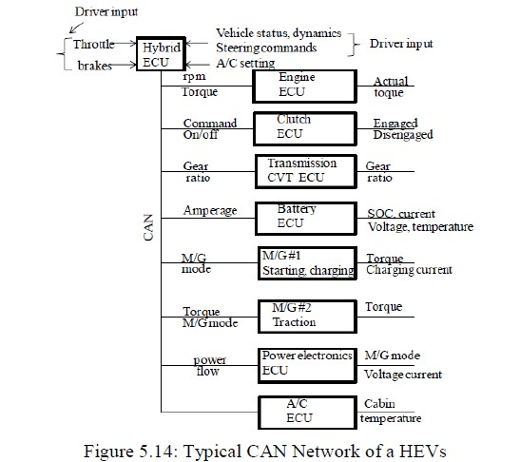

In CAN most data can be updated every 10ms and the data is checked to assure data reliability.

**Control Variables** The control variables connect various ECUs with each other and fall in one of the three categories:

i. mechanical

ii. electrical

iii. discrete

The control variables falling in the mechanical category are:

1. All the variable related to ICE

2. Gear ratio

3. Rpm of each rotational component

The control variables falling in the electrical category are:

1. Currents in the batteries, inverters and EM

2. Voltages across EM, inverters and battery terminals

3. EM torque

The variables are like yes/no or on/off and HEVs have a few such variables such as:

1. EM mode: motor or generator?

2. Gear ration: which of the ***n*** available gears?

3. Clutch: engaged or disengaged

**Power and data networks:**

Modern vehicles, and particularly hybrid vehicles, are evolving to a four layer power and data communications architecture. The four layer model is based on broad classes of functionality, data transmission speed and data protocols associated with broad classes of speeds.

In-vehicle architectures, besides being open, are hierarchical by design. A hierarchical architecture adheres to strict protocols of top down command flow and upward flow of data.

Lateral data flow is allowed, but lateral command flow is prohibited. This is the architecture of choice for hybrid propulsion in which a high level vehicle system controller coordinates its various subsystems as shown in Figure 5.15

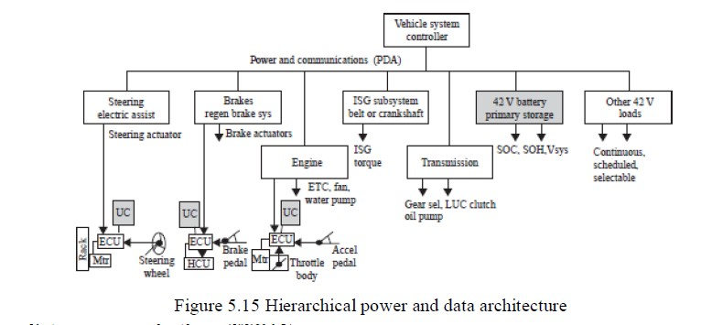

**Future communications: TTCAN**

 Controller area networks (CANs) are event triggered protocols covered under ISO specification 11898 for data link layer communications.

 Future by-wire technologies require time triggered communications protocols so that closed loop control is consistent and free of network latency issues.

 To mitigate latency issues, time triggered CAN (TTCAN) is being proposed that can schedule messages either as event driven or time triggered without excessive software overhead and minimal additional cost.

 As more and more of the vehicles subsystems are linked there is a need for fast sensor data sharing and real time performance in the associated controls.

 It is also necessary that the communications channel link with the instrument cluster (human–machine interface) for feedback to the operator on system status.

 TTCAN’s controller would trigger the appropriate sensor for its data and share these data with the affected modules.

 With TTCAN, bus synchronization and time triggering boost bus availability to about 90% of capability.

 This is because with only a single message on the bus loss of arbitration is prevented and channel latency becomes entirely predictable.

 In the case of using a CAN physical layer with TTCAN this puts an upper limit of approximately 1 Mb/s on bus loading.

Because of the flexible event and time triggering options, TTCAN has been called MultiCAN by some manufacturers

The benefit of TTCAN lies in the fact that existing network physical medium and channels remain intact and the time triggering along with synchronization of the bus and all connected modules shifting from local to global time without the need for expensive hardware or replacement of the network medium.

 The protocol is at the proposal stage and will be offered as part of manufacturers 32- bit microcontrollers.



**SELECTION OF SUPPORTING SUBSYSTEM:**

It should be understood that hybrid vehicles require electrically augmented steering, braking and climate control systems.

The vehicle steering system must be full electric assist, or electric over hydraulic, as a minimum to ensure that steering boost is available even with the engine off, regardless of whether the vehicle is at rest or in motion. Similarly for the brakes since engine vacuum is not available during idle–OFF mode.

In fact, some mild hybrid implementations use separate electrically driven vacuum pumps for the brakes during engine-off periods. Cabin climate control is the most energy intensive engine-off load. The following subsections elaborate on each of these topics.

The supporting subsystems in the EV/HEV are

1. Steering system

2. Braking system

3. Cabin Climate Control

4. Thermal Management

5. Human Machine Interface

**STEERING SYSTEMS:** As a general rule of thumb, when a vehicle steering mechanisms rack load exceeds about 8 kN, a low voltage, dc brush motor, electric assist may be inadequate for acceptable steering boost performance. The range of rack loads from 8 kN to roughly 12 kN defines a transition during which 14 V electric assist must give way to 42 V PowerNet systems.

The low voltage 14 V power supply is not adequate to source the instantaneous power demanded by steering systems having high rack loading. Above 12 kN of rack load, regardless of vehicle type, the electric assist steering is best served from a 42 V Power Net vehicle power supply.

BEVs will generally operate their electric assist steering from the traction battery. However, this requires attention to high voltage cabling and proper circuit protection. For distribution voltages greater than 60 V, it is accepted practice to contain high voltage cabling within orange jacketed sleeves or to use orange coloured cable insulation.

**BRAKING SYSTEMS:**

A hybridized vehicle does not inherently require electric assist (electrohydraulic or electromechanical) brake gear. Vehicle operation can be maintained in hybrid mode with conventional foundation brakes, but energy recuperation will fall significantly short of expectations.

Even grade holding does not require any special brake subsystems. Some mild hybrid vehicles rely on simple electric driven booster pumps to maintain brake line pressure to hold a grade.

When performance is required it is common to implement EHB in order to offer optimum energy recuperation, grade holding and vehicle stability.

An EHB system consists of two main components: (1) a hydraulic electronic control unit, HECU, that replaces the production ABS unit (pump, accumulator and pressure modulators) and (2) an actuator control unit (ACU) that replaces the conventional master cylinder and booster assembly.

Figure 4.53 illustrates some typical HECU and ACU hardware that constitute an EHB system.

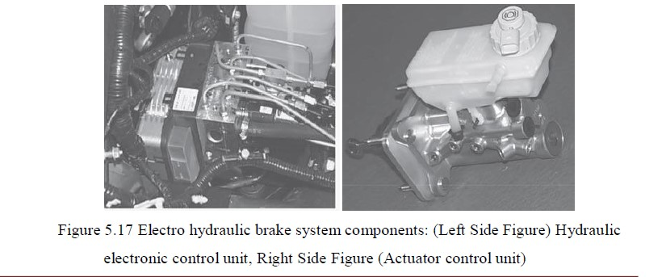

In Figure 5.17 the ACU consists of a conventional master cylinder, a reservoir, plus brake pedal pressure and speed sensors. The HECU houses the motor-pump, an accumulator, valve body to regulate line pressures and electronics to control the valve operation.

It should be appreciated that during the first pressurization of the HECU accumulator hydraulic lines between the motor driven high pressure pump and accumulator may become very hot until the accumulator pressure builds up sufficiently so that fluid flow is reduced.

In addition to providing full regenerative brake capability, the EHB system also maintains proper front–rear brake balance, provides ABS functionality when commanded and is fully compatible with all vehicle stability programmes.

**CABIN CLIMATE CONTORL**

Actively controlled air conditioning is a necessity in hybrid vehicles. Cabin climate control ranges from cold storage boxes such as the cold storage unit used in the prototype ES environmental vehicle build by Toyota, to hybrid drive air conditioning compressors.

A hybrid drive air conditioning compressor unit consists of the conventional A/C belt driven compressor plus a clutch mechanism and linkage to a separate electric motor and controller that is used to drive the pump when the engine is off. In such a system a brushless dc motor rated 1.5–2.0 kW at 42 V is used to maintain cabin cooling during idle–OFF intervals.

A/C compressors used in hybrid vehicle climate control systems are of the two stage, rotary vane, variable displacement type. When the A/C compressor is engine driven, the displacement is highest to provide sufficient coolant flow to the passenger cabin evaporator assembly during cabin temperature pull-down.

When the A/C compressor is brushless dc motor driven, the displacement is lower since only 1.0–1.5 kW of drive power is needed to maintain cabin temperature within the comfort zone.

**THERMAL MANAGEMENT:**

Managing the thermal environment within the complexity of a hybrid powertrain requires close attention to package locations, airflow patterns and vibration modes.

 Today’s electronic modules are fabricated with very low mass, surface mounted devices (SMD) plus chip and wire on ceramic substrates, to tolerate such conditions.

 Vibration transmitted along the vehicle powertrain originates from the engine itself due to misfire (now very infrequent) to pre-detonation due to improper timing and/or improper fuel blends, to engine hop due to its moving components

Resonance can also play a role, but these tend to be at low frequencies in the range of powertrain bending and engine hop.

 Higher frequencies are generated by crankshaft whirl due to imbalance and journal bearing wear out.

 Figure 5.18 illustrates schematically the various regions of temperature and vibration extremes.

Figure 5.18 Powertrain package environmental zones

**HUMAN MACHINE INTERFACE**

Production vehicle clusters, or instrument panels as many customers prefer to call them, are used to display standard vehicle functions such as speed and engine rpm, along with indications of battery status, coolant temperature and oil sump temperature.

 Figure 5.19 illustrates one technique used to make the instrument cluster, the HMI, more interactive with the customer by showcasing the hybrid functionality of an HEV by putting special emphasis on the battery system.

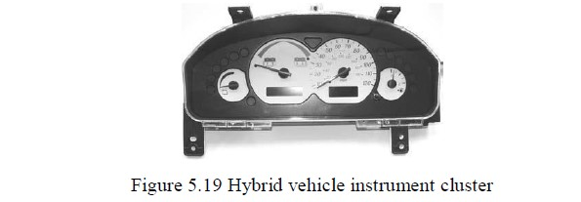

The HV cluster shown in Figure 5.19 has two unique gauges – an energy available gauge and an electric power charge/assist gauge – plus the necessary warning lamps to alert the operator of hybrid functional failure.

Gear shift position in a production vehicle is displayed using mechanical linkages, whereas in a hybrid vehicle this information is in electronic display format on the HV cluster.

 The panel illumination circuits on the HV cluster may also be different from a conventional vehicle cluster

**OVERVIEW OF CONTROL SYSTEM:**

**The Electronic Control Unit (ECU)** Typical control architecture of HEV is shown in **Figure 5.20**

. In **Figure 5.20** it can be seen that there are multiple ECUs such as:

i. Hybrid ECU

ii. ICE ECU

iii. EM ECU

iv. Transmission ECU

v. Power Electronics ECU

vi. Battery ECU or Battery Management System A brief description of each of the ECUs is given below.

**Hybrid ECU:** The Hybrid ECU is in command of all other ECUs and selects the operational mode based on the driver’s input. The hybrid ECU is responsible for system wide energy management. Typically the goal of control is to minimize the fuel consumption.

For each litre of petrol, the hybrid ECU tries to provide maximum mileage. To do this, the hybrid ECU allows or prohibits ICE shutoff. The hybrid ECU commands

1. The amount of torque and power from the motor and ICE

2. The amount and timing of power generation to charge battery.

**ICE ECU:** This ICE ECU is responsible for to operate the ICE Engine Mode then converters from heat energy to mechanical energy (Propulsion energy). The propulsion energy gives to the driving axle wheel of the vehicle. This vehicle movement is mainly operated from the ICE ECU, these ICE ECU received command from the Hybrid ECU, when the input is given to the Hybrid ECU. **EM ECU:** The EM ECU is responsible for switching of the EM from motoring mode to the generator mode and also controls the motor to deliver the torque demanded by the hybrid ECU.

The EM ECU consists of various control strategies such as Constant Torque Control, Field Weakening Control, etc. Transmission ECU: The transmission ECU provides the correct gear ratio to control the torques and angular speeds of the EM and the ICE.

Power Electronics ECU: Having power from a battery is only the first step. The power must be delivered to the EM, in the motoring mode, at the voltage and current needed. For regenerative braking, the power must be accepted from the EM.

The function of the power electronic ECU is to receive commands from hybrid ECU, to control inverter energy flow both ways, that is, charge and discharge, to control switching of EM between motor and generator modes and to control switching of EM between motor and generator modes.

**Battery ECU or Battery Management System:** The battery ECU or the battery management system (BMS) monitors and measures temperature and assures cooling is adequate.

The BMS avoids the stress of heat and over-temperature and the effects of excessive charging or discharging are eliminated or lessened. The BMS is essentially for long battery life and optimum fuel efficiency.

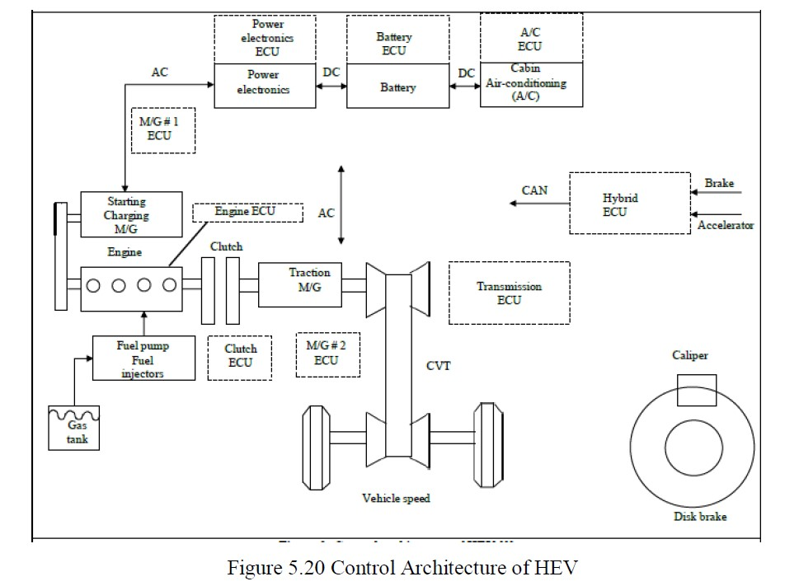

**Communication Protocol: CAN**

A typical CAN network in an HEV is shown in **Figure5.21**. The CAN is a fast, high rate network enabling communication between ECUs

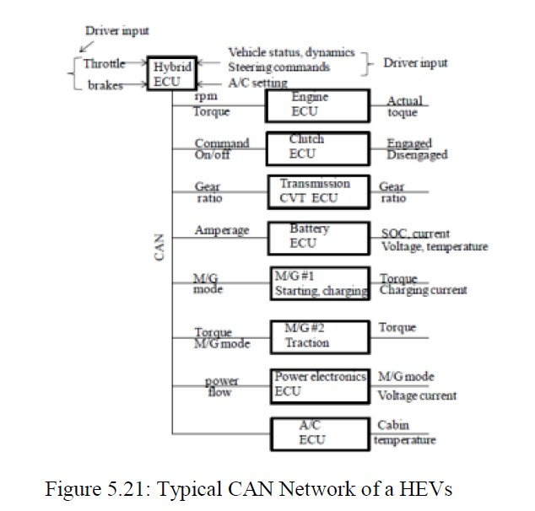

In CAN most data can be updated every 10ms and the data is checked to assure data reliability.

**Control Variables** The control variables connect various ECUs with each other and fall in one of the three categories:

i. mechanical

ii. electrical

iii. discrete

The control variables falling in the mechanical category are:

4. All the variable related to ICE

5. Gear ratio

6. Rpm of each rotational component

The control variables falling in the electrical category are:

4. Currents in the batteries, inverters and EM

5. Voltages across EM, inverters and battery terminals

6. EM torque

The variables are like yes/no or on/off and HEVs have a few such variables such as:

4. EM mode: motor or generator?

5. Gear ration: which of the ***n*** available gears?

6. Clutch: engaged or disengaged

**ENERGY MANAGEMENT STRATEGIES - CLASSIFICATION:**

The hybrid ECU is the heart of the control architecture of any HEV and it is also known energy management strategy (EMS). The EMS can be classified into following broad categories:

i. Rule based

ii. Optimization based

**The Rule Based strategies consist of following subcategories:**

**i. Fuzzy based:** The fuzzy based control strategies are of three types

a. Predictive,

b. Adaptive

c. Conventional

**ii. Deterministic Control:** The deterministic controllers are subdivided into

a. State Machine

b. Power follower

c. Thermostat Control.

**The Optimization based strategies are of following types:**

**i. Global Optimization:** The global optimization methods are:

a. Linear programming methods

b. Dynamic Programming

c. Stochastic Dynamic Programming

d. Genetic Algorithms

**ii. Real time Optimization: The real time optimization techniques are of following types:**

a. EFC minimization

b. Robust control

c. Model predictive

d. Decoupling Control

In **Figure 5.22** the classification tree of the various control techniques is shown. In the subsequent sections the Rule based control strategies will be discussed in detail.

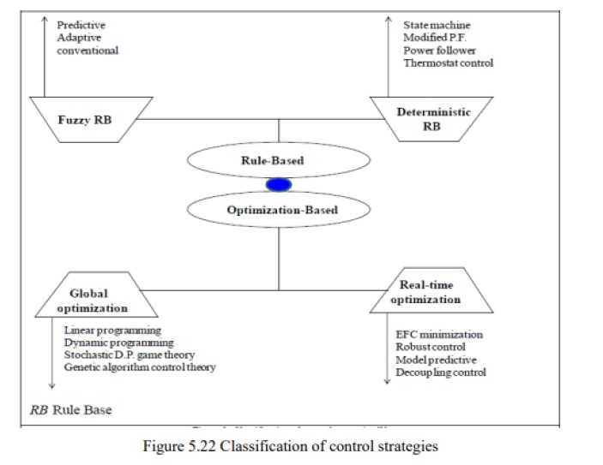

**Basic Principles of Rule Based Control Methods:**

Rule based control strategies can cope with the various operating modes of HEV. The rule based strategies are developed using engineering insight and intuition, analysis of the ICE efficiency charts shown in **Figure 5.23** and the analysis of electrical component efficiency charts.

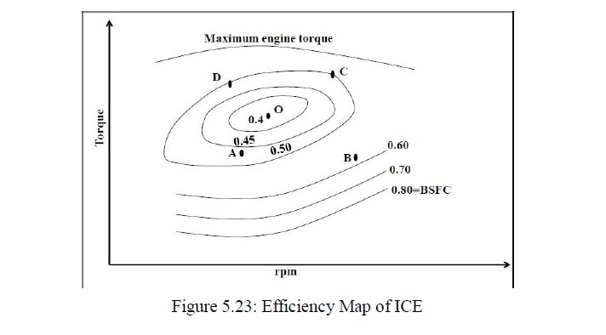

An example of developing rule based strategy can be explained using the ICE efficiency map shown in **Figure5.24** The lines, which are drawn using engineering insight and intuition, divide the map into three regions: **A**, **B**, and **C**.

The rules for operation of ICE in these three regions are:

i. In the region **A** only EM is used because in this region the fuel efficiency of the ICE is poor.

ii. In region **B** only ICE is used since this the region of high fuel efficiency.

iii. In region **C** both ICE and EM are used.

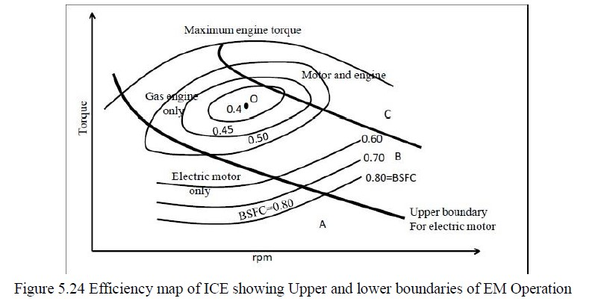

**Deterministic Rule Based Strategies** Heuristics based on analysis of power flow in HEV drivetrain, ICE efficiency map and human experiences are utilized to design deterministic rules. These rules are generally implemented using lookup tables to split requested power between the ICE and EM. The most commonly used strategies are:

➢ Power follower control 

➢ State Machine based controller 

➢ Modified power follower 

➢ Thermostat (on/off) control 

**Power follower control:** In this strategy the ICE is the primary source of power and the EM is used to provide additional power when needed by the vehicle. Care is always taken to maintain the SOC of batteries within safe limits. The rule base that is generally used is:

i. Below a certain minimum vehicle speed, only the EM is used.

ii. If the demanded power is greater than the maximum power that the ICE can produce at its operating speed, the EM is used to produce excess power

iii. The EM charges the batteries by regenerative braking.

iv. The ICE shuts off when the power demand falls below a limit at the operating speed. This is done to prevent inefficient operation of ICE.

This is a very simple and effective strategy but the major disadvantage is that the efficiency of the entire drivetrain is not optimized

**State machine based** the state machine dictates the operating mode of the hev such:

▪ engine (ice propelling the vehicle)

▪ boosting (both ice and em propelling the vehicle)

▪ charging (ice propelling the vehicle and charging the battery) The transition between the operating modes is decided based on:

▪ the change in driver demand

▪ a change in vehicle operating condition

▪ a system or a subsystem fault.

the various states involved in the control strategy are listed in **table 1**

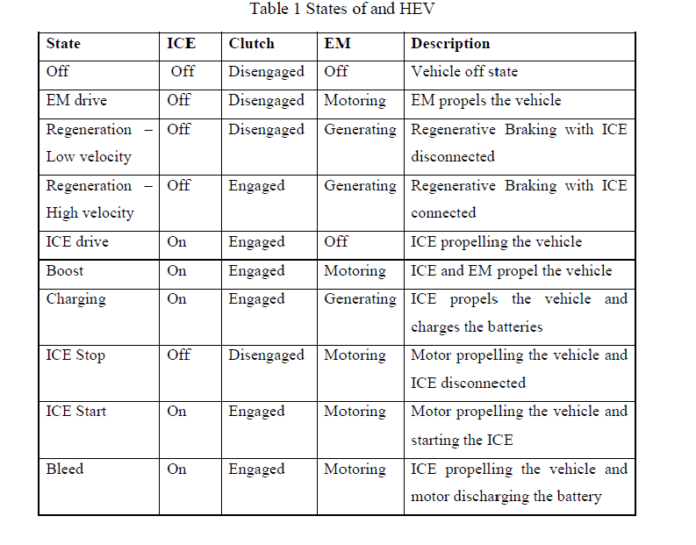

**FUZZY LOGIC CONTROL:**

**Why Fuggy Logic (FLC) Based Controllers for HEVs:**

Looking into a hybrid drivetrain as a multidomain, nonlinear and time varying plant, fuzzy logic seems to be the most logical approach to the problem. Instead of using deterministic rules, the decision making property of fuzzy logic can be adopted to realize a real time and suboptimal power split.

Fuzzy logic is an extension of the conventional rule-based methods and has following advantages over them:

1. ***Robustness*:** It is inherently robust because it does not require precise, noise free inputs and the output is a smooth function despite a wide range of input variations.

2. ***Adaptation*:** Since FLC processes user defined rules governing the system, it can be modified easily to improve or drastically alter system performance.

3. ***Flexibility*:** FLC is not limited to a few feedback inputs and one or two outputs and it is not necessary to measure or compute rate-of-change of parameter

**How to Use Fuzzy Logic in Design of Controllers:**

The energy management and control strategy using FLC performs following actions:

1. maximizes fuel economy, minimize emissions and distribute the driver’s request for power between two sources: ***ICE*** and ***Motor***.

2. maximize fuel economy at any point in operation, that is, provide dynamic or instantaneous optimization.

3. maximize some other attributes such as acceleration of vehicle

In **Figure 5.25** the generic schematic diagram of FLC is shown. The four components of FLC, as shown in **Figure 5.25**, are:

1. Fuzzification, which is the change from crisp values to fuzzy values. For ICE speed, the crisp value may be 2000rpm and a possible rule for ICE speed may be “If ICE rpm is too low, then inject more fuel”. The fuzzy value associated with the “If X, then Z” statement would be for X<2000 rpm.

2. Rule base has a collection of rules: several hundred rules may be developed and applied.

3. Inference applies the defined rules to the inputs.

4. Defuzzification transforms the results of the inference process to crisp outputs.

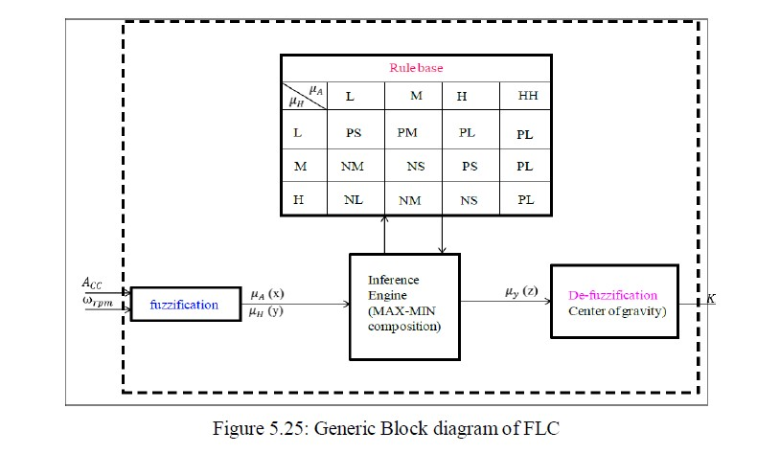

**Fuzzy Strategy:**

The FLC, explained in this section, satisfies the following objectives:

• minimize NOx emissions

• sustain battery SOC

• achieve desired torque requested by the driver The inputs to this FLC are:

• Acceleration pedal stroke (Acc)

• EM speed ( ώem )

The configuration of the drive train is shown in **Figure 5.26**. An induction motor (IM) used in the drivetrain and the IM is directly coupled to the ICE. Since the IM is directly coupled to the diesel ICE, it will be in the field weakening region in most of the ICE operating, the generating torque decreases as the ICE speed increases.

Hence, it is required to describe the required torque as a ratio defined as *K* to the rated torque at a rotational speed. The positive *K* means that the IM acts as a powering source and negative *K* means that the IM acts as a generator. Once *K* is determined, the torque command becomes

Torque Command= *K \** rated torque at a rotational speed (1)

Figure 5.26: Drive train Configuration

Some basic principles of generating the torque command from the acceleration pedal stroke and ICE rotational speed in the HEV can be described as follows:

***1. Low ICE Speed:*** When the ICE rotational speed is low, it generates pollutant emissions with low fficiency. Hence, in this operating condition, the torque assistant control by the IM should be performed. Assistant torque is commanded to increase in proportion to the acceleration pedal stroke as in the conventional ICE vehicle, that is:

*K* *acceleration pedal stroke (2)

***2. Medium ICE Speed:*** When the diesel ICE’s speed is medium, it can supply sufficient torque to the hybrid drive train. Hence, battery recharging control is performed instead of torque assistance control when acceleration pedal stroke is below some extent. The torque assistance of the IM should be achieved to satisfy the driver’s acceleration need if the acceleration pedal is pressed beyond some extent. Since, the diesel ICE torque is subjected to saturation beyond 80% of the pedal acceleration pedal stroke; the motoring action of the IM is made to begin from that point.

***3.High ICE Speed:*** When the diesel ICE speed is high, the torque assistance control is performed as that of the medium speed range. In battery recharging control the IM’s output power is kept constant. Now since the ICE can produce more power than in the medium speed range, the factor should be made to be negatively greater in order to supply more power to the batteries than that of

the medium speed range. As the speed increases, the ratio of the power capability of the ICE to that of the IM increases. Hence, it is beneficial to recharge the battery at high speed, rather than at medium speed.

**(OR) Classification of Energy Management Strategies:**

we propose a new hierarchical classification scheme of EMSs for all kinds of Hybrid Electric Vehicles via two main headlines: (1) offline EMSs are categorized according to the information level of the driving conditions utilized, including global optimization based-EMSs and rule-based EMSs; and (2) online EMSs are represented as instantaneous optimization-based EMSs predictive EMSs, and learning-based EMSs. The classification of the EMSs is illustrated in Figure 5.27 below. It is noted that a flexible EMS can include a mixture of various techniques (offline and online) to form an integrated EMS for improving the fuel economy and performance.

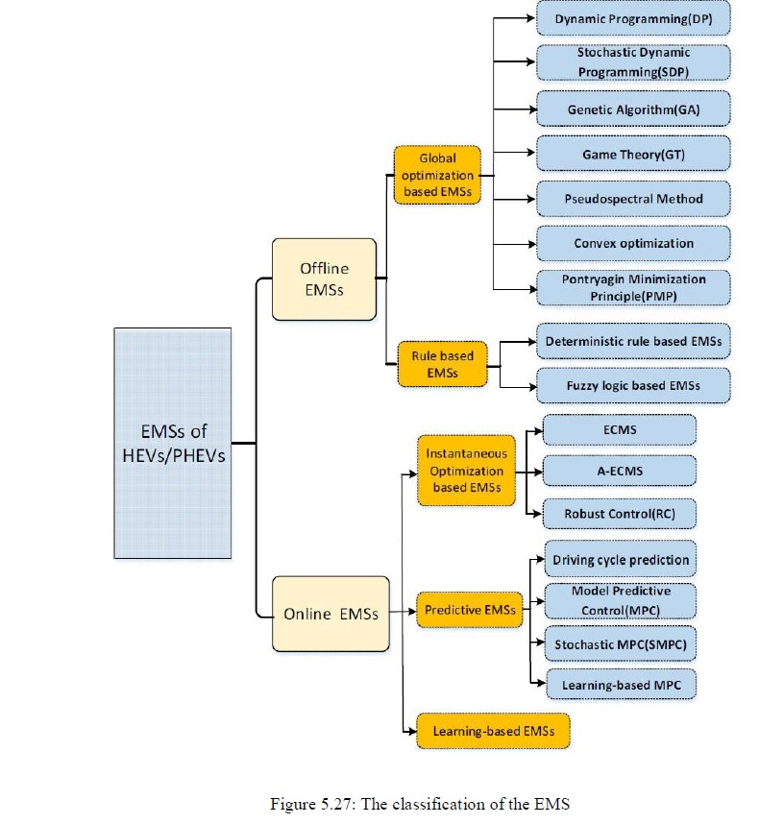

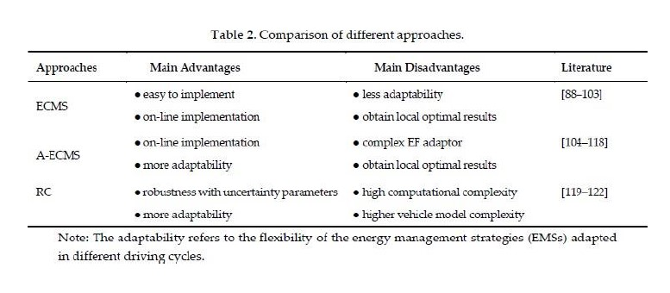

**ENERGY MANAGEMENT STRATEGIES - IMPLEMENTATION:**

**Implementation of Fuzzy Logic:**

Based on the three principled of operation of ICE, discussed above, the fuzzy rule base can be developed. The development of the FLC is described in the following subsections.

***Input / Output Membership Functions for Fuzzy Logic:*** For the considered example, there are two input variables namely:

1. The acceleration pedal stroke Acc

2. The IM rotational speed ώrpm

The ranges of the input variables are set as follows:

1. The Acc is set to zero when the driver does not press the acceleration pedal at all and set to a 100 when the driver presses the acceleration pedal completely.

2. The ώrpm can vary from the diesel ICE’s idling speed to its maximum speed.

The output is the normalized ratio of the torque command to rated torque at a speed. The inputs and the outputs are normalized between zero and one. The input and the output membership functions are shown in **Figure 3**.

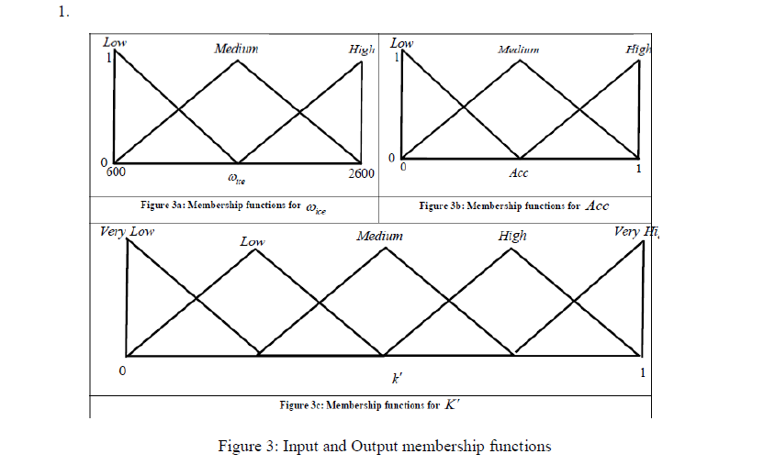

***Rule Base for Fuzzy Logic:***

The rule base for the torque control and battery recharging control are given in **Table 1**.

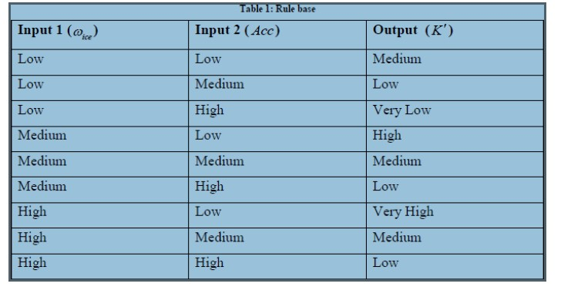

***Procedures and Results of Fuzzy logic*:**

